**(Q) What are the new tags added in HTML5 ?**

**A.** The following tags (element) have been introduced in HTML5 –

|  |  |
| --- | --- |
| <header> | Represents a group of introductory or navigational aids. |
| <nav> | Represents a section of the document intended for navigation. |
| <article> | Represents an independent piece of content of a document, such as a blog entry or newspaper article. |
| <section> | Represents a generic document or application section. |
| <aside> | Represents a piece of content that is only slightly related to the rest of a page. |
| <footer> | Represent a footer for a section and can contain information about the author, copyright information, et cetera. |
| <time> | Represents a date and/or time. |
| <canvas> | This is used for rendering dynamic bitmap graphics on the fly, such as graphs or games. |
| <embed> | Defines external interactive content or plugin. |
| <meter> | Represent a measurement, such as disk usage. |
| <video> | Defines a video file. |
| <audio> | Defines an audio file. |
| <command> | Represents a command the user can invoke. |
| <keygen> | Represents control for key pair generation. |

**(Q) How to embed audio and video in a webpage?**

**A.** The HTML5 <audio> and <video> tags make it simple to add

media to a website.

**Audio Input:**

<!DOCTYPE html>

<html lang="en">

<head>

    <meta charset="UTF-8">

    <meta name="viewport" content="width=device-width, initial-scale=1.0">

    <title>Document</title>

</head>

<body>

    <div style="background-color: aquamarine;">

    <h2>Click to play</h2>

    <audio src="C:\Users\makavana tushar\Downloads\mixkit-classic-alarm-995.wav" controls></audio>

</div>

</body>

</html>

**Audio Output:**

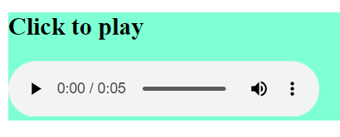

**Video Input:**

<!DOCTYPE html>

<html lang="en">

<head>

    <meta charset="UTF-8">

    <meta name="viewport" content="width=device-width, initial-scale=1.0">

    <title>Document</title>

</head>

<body>

    <div style="background-color: burlywood;">

    <h2>Click to play</h2>

    <video src="C:\Users\makavana tushar\Downloads\WhatsApp Video.mp4" controls></video>

</div>

</body>

</html>

**Video Output:**

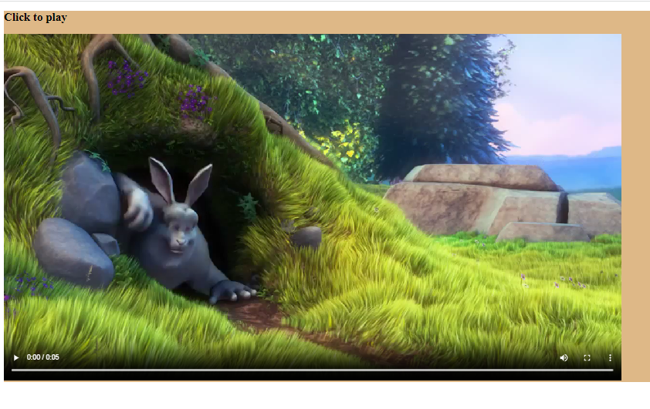

**(Q) Semantic element in HTML5?**

**A.** A semantic element clearly describes its meaning to both the developer.

**Example:**

<form>, <table>, <article>.

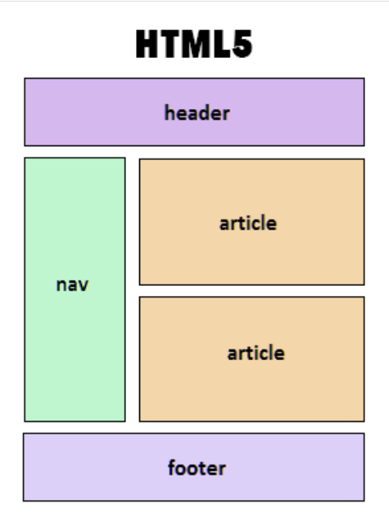

**(Q) Canvas and SVG tags**

**A.**

|  |  |
| --- | --- |
| Canvas | SVG |
| Resolution dependent | Resolution independent |
| No support for event handlers | Support for event handlers |
| Poor text rendering capabilities | Best suited for applications with large rendering areas (Google Maps) |
| You can save the resulting image as .png or .jpg | Slow rendering if complex |
| Well suited for graphics-intensive games | No suited for game applications |
| Vector based (composed of shapes) | Raster based (composed of pixel) |
| Modified through script and CSS | Modified through script only |

**SVG Input:**

<!DOCTYPE html>

<html>

<head>

    <style>

        #one {

            position: relative;

            left: 50%;

            -webkit-transform: translateX(-20%);

            -ms-transform: translateX(-20%);

            transform: translateX(-20%);

        }

    </style>

</head>

<body>

    <h2 align="center">SVG Circle</h2>

    <svg id="one" height="200">

        <circle id="greencircle" cx="60"

            cy="60" r="50" fill="green" />

    </svg>

</body>

</html>

**SVG Output:**

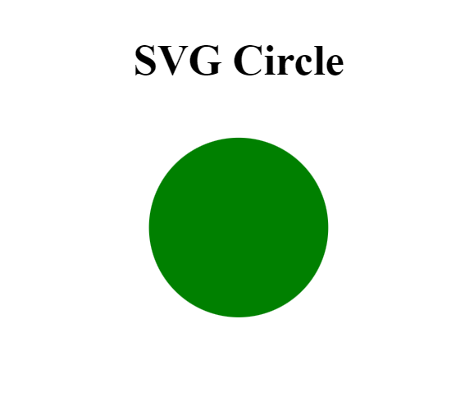

**Canvas Input:**

<!DOCTYPE html>

<html>

<head>

</head>

<body>

    <h2>Canvas Square</h2>

    <canvas id="one" width="100" height="100"

        style="border:1px solid #000000;">

    </canvas>

    <script>

        var c = document.getElementById('one');

        var ctx = c.getContext('2d');

        ctx.fillStyle = '#7cce2b';

        ctx.fillRect(0, 0, 100, 100);

    </script>

</body>

</html>

**Canvas Output:**

